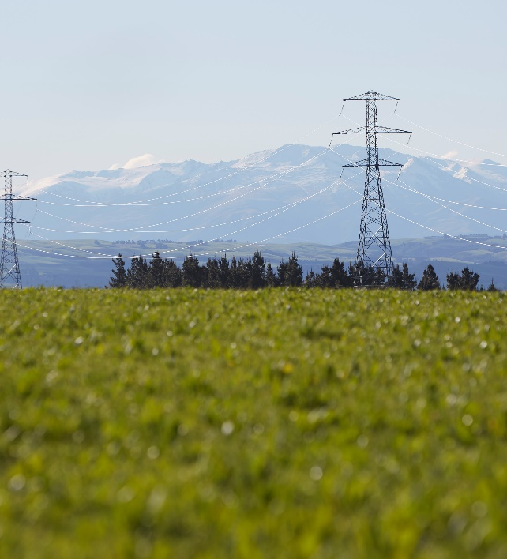

Transpower is exploring non-transmission solutions in the upper South Island to help defer transmission and distribution investment and offer lower-cost options for New Zealanders, while continuing to meet rapidly growing electricity demand.

Upper South Island
  - Non-transmission solutions
Information Sheet | February 2026

Background information
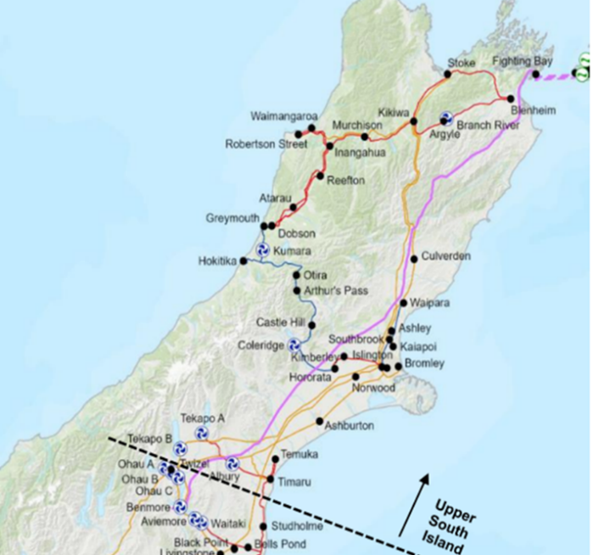
We are investigating possible electricity infrastructure investments for our upper South Island network to ensure a reliable future power supply as the region grows and more homes and businesses switch their energy use to electricity.
This critical network allows all areas north of Twizel to access lower cost and reliable electricity produced by the major hydro generation schemes to the southwest of the South Island.
Demand in the South Island has been rising consistently in recent years, especially in summer when irrigation significantly increases power usage. This trend is set to continue as the region grows and electrifies, through the adoption of electric vehicles and the replacement of coal for industrial processes.
Part of our investigation includes the consideration of non-transmission solutions (NTS) such as demand response strategies, where industrial customers, flexibility service providers or electricity retailers work to shift electricity demand away from peak demand periods, reducing or delaying the need to upgrade or build new lines.
Our investment proposal will future proof electricity supply to an extensive part of the South Island into the 2030s, enabling its communities to grow, and people and businesses to thrive.

Draft approval from the Commerce Commission
In December 2025, the Commerce Commission announced its draft approval of our $193 million investment proposal for the upper South Island network, to ensure we can continue to meet rapidly growing electricity demand.
Our investment proposal includes $7 million to identify and implement NTS. These initiatives can help reduce electricity demand during peak usage, improving the performance of existing infrastructure and reducing or delaying the need for upgrades or new lines.
An NTS strategy could play a role in deferring transmission investment, aiding in managing the uncertainty associated with potential large step load changes (e.g., dairy and aviation electrification in Canterbury) and mitigating risks of delays in constructing transmission assets in support of our investment proposal.

Capacity constraint forecast
As electricity demand continues to grow, more power will need to be transferred up the South Island, requiring voltage support to maintain a stable power supply. Without appropriate transmission investments in the upper South Island, reliability may be constrained by 2029, necessitating a flexible NTS to manage and address these projected constraints.
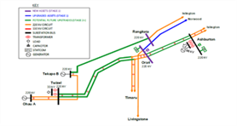
Current estimates indicate a demand response requirement of up to 34MW in winter and 93MW in summer, with possible shoulder period activity. These figures may change as updated load forecasts become available from local lines companies.
We are targeting the following Grid Exit Points (GXPs) for NTS, which provide the greatest value for deferral, however we are open to other GXPs.
- Ashburton - ASB
- Islington - ISL
- Timaru - TIM
- Temuka - TMK
- Norwood - NWD

Upcoming initiatives – request for proposals
If the Commerce Commission gives its final approval for the inclusion of the $7 million NTS allowance, we plan to issue a request for proposals (RFP) for flexibility solutions providers around late Autumn 2026.
We are interested in new flexibility solutions for summer, winter, and potential shoulder periods that are not already reserved by other programs, and do not conflict with proposed 'active' times for upper South Island NTS.
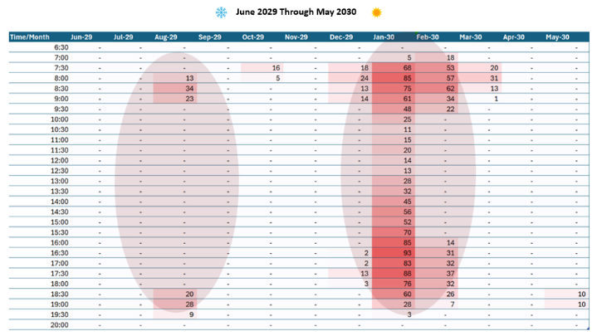
Proposals will be evaluated on economic benefit against the transmission option and we will also consider supplier capability and implementation risk as well as coordination with local lines.
If successful, this initiative could demonstrate how coordinated flexibility services can support the national grid in accelerating flexibility across Aotearoa.
Want to find out more?
For more information please email us at demandresponse@transpower.co.nz or visit our upper South Island project page.

Figure above: Forecasted demand response required by 2029/2030
Note: This information is based on a prudent load forecast which will be updated yearly as we move closer to the need date.

